Sideshow Bob

Team

**Project**: Car Dealership Basic Manage System

Members:

# stann1 (Станислав Стойчев)

# ivivanov (Иван Иванов)

# rodi1i (Радослав Стоянов)

# SNeykov (Strahil Neykov)

# ekostadinov (Евгени Костадинов)

# Project Description

The target for our team is to design and implement **an object-oriented application** for a car dealership’s business purposes. Our system provides basic but essential functionality for not only the central-base Dealership, but for its branches too. This product meets all basic requirements for modern and flexible business application software. And in the same time it can be extended with additional functionality very easily.

## General Requirements

We not only meet all general task requirements, but in some aspects even overdid them. Our application implement several different interfaces, tens of various classes (including abstract, inheritors and etc.). The exceptions are thrown correctly and properly handled. Our Struct implementation is on Car Dealership’s address and contacts. Since the software product is designed to manage and handle large amounts of resources the enumerations are not restricted to just one. As events we provide on-click button and we have implemented INotifyPropertyChanged interface. Our application have event handler on command-call CanExecutedChanged. And as design pattern we use Singleton on AuthorisedDealer class.

## Additional Requirements

* As every serious team of software developers we strictly follow and execute the best practices for OO design: using data encapsulation, exception handling, usage of delegates and events is like it is recommended in MSDN, use of inheritance, abstraction and polymorphism is proper, the principles of strong cohesion and loose coupling are followed.
* Our choice of **Team Foundation Server (TFS)** and keeping the source code for team collaboration we use <http://tfs.visualstudio.com> and to be more specific You may find us at: https://sideshowbob.visualstudio.com/DefaultCollection/SideshowBob
* To visualize all types provide a **class diagram** :

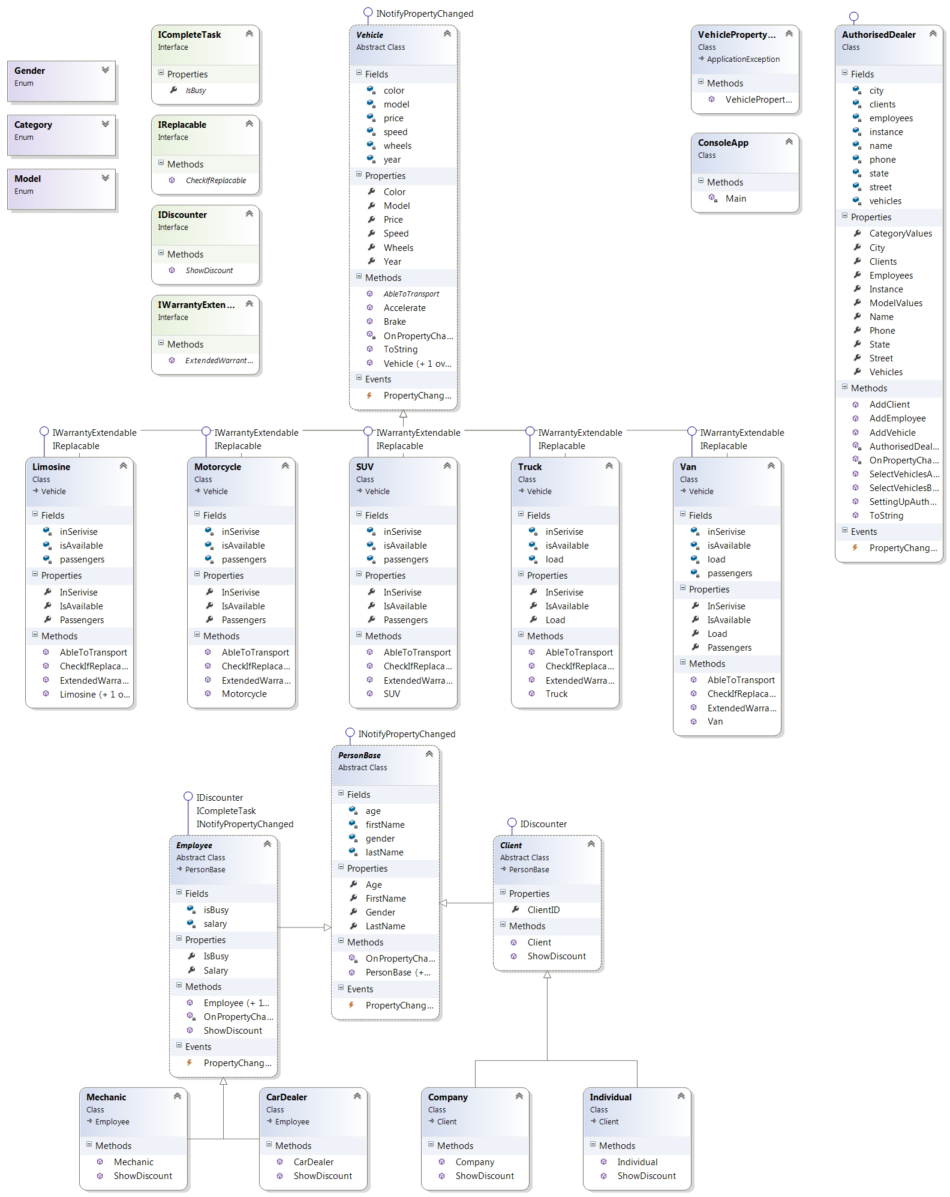

## And a GUI Diagram:

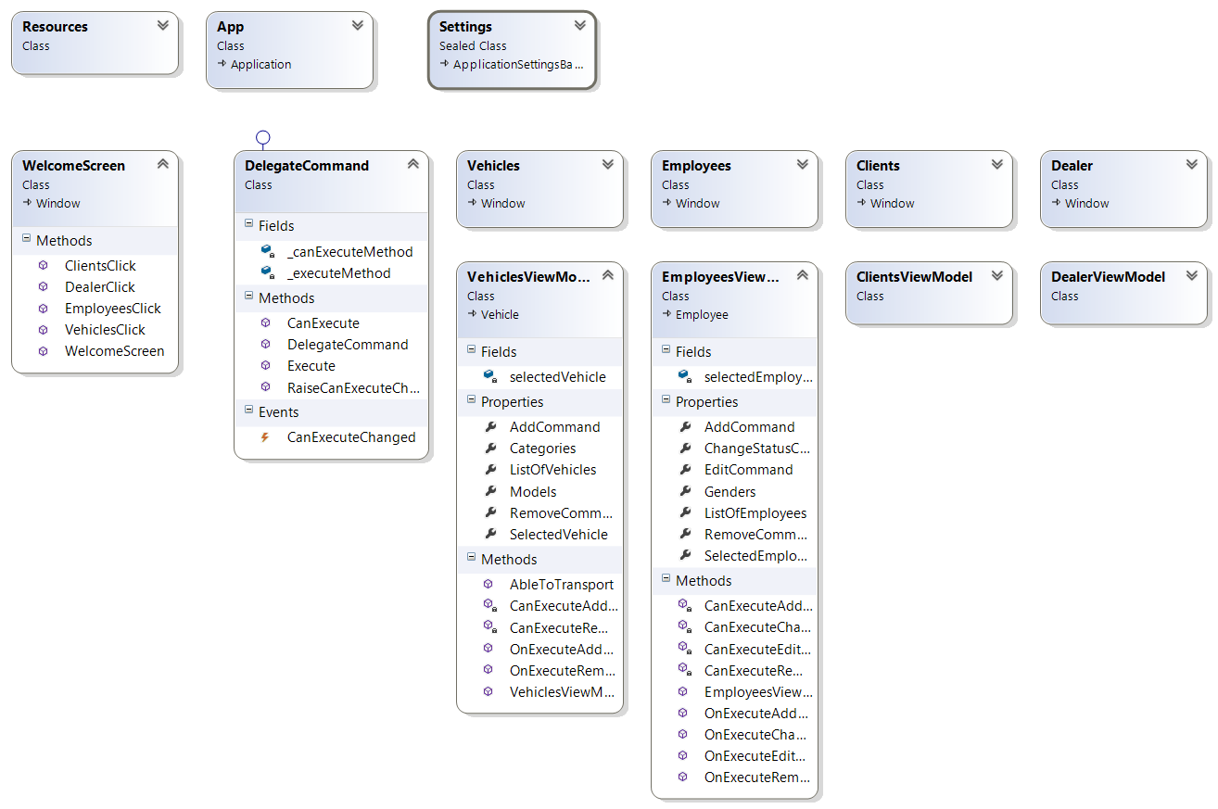

## Optional Requirements

Since we had a chance, time and a suitable situation, we add some of the following to our project:

* **Static members** (fields, properties, constructor, etc.)
* **LINQ**
* Implementation of **ToString()** override

## Non-Required Work

* As team of deeply motivated and open-minded software engineers we’ve created and implemented **User interface (UI)** that is reliable and user-friendly. We provide graphical user interface (GUI) for the car dealers and service mechanics.
* Such a big and responsible project cannot be **completely finished in a short time-span** even from a skillful and large team. We consider this team work project for educational purpose, but we want also to prove that we can create and develop it furthermore. Our main purpose is not only to experience **object-oriented modeling** and **OOP** in a real-world project, but to get some experience in **team working** and team collaboration with TFS.